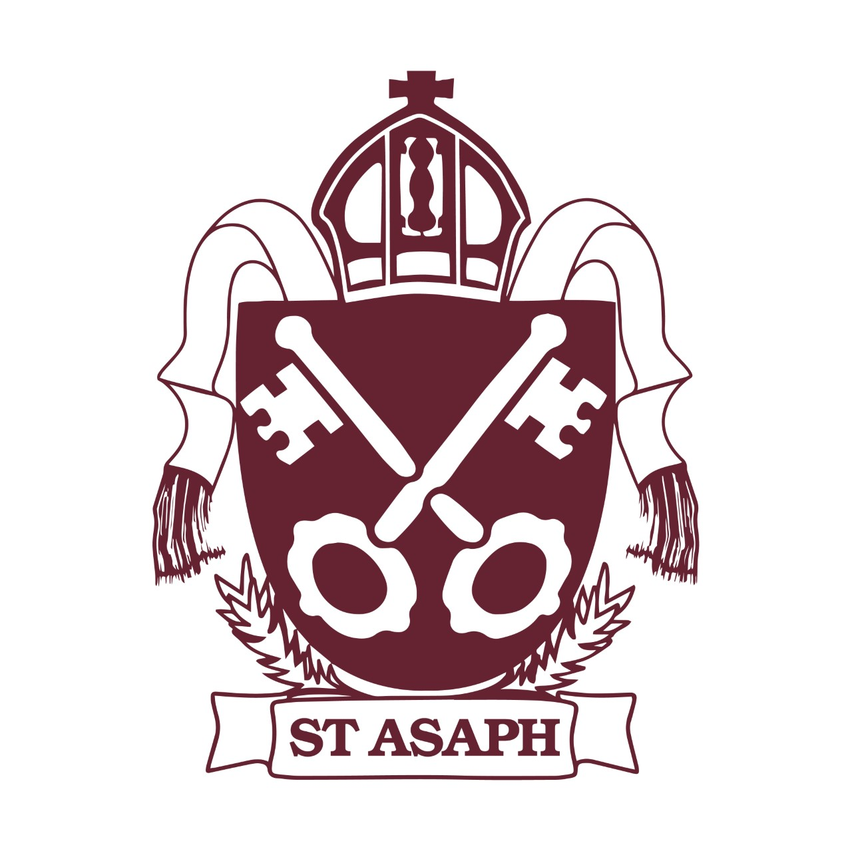
Ysgol yr Holl Saint – All Saints’ School

School Council

Date: 16.02.23
Present: all present

Agenda | Actions
Welcome – all present  Book Fair  - SC keen to be involved in organising and hosting a coffee morning / afternoon  - SC would like all pupils to dress up as their favourite book character during one day of the Book Fair week and for each class to decorate their classroom door as their favourite class book  Comic Relief  - SC have voted to wear pyjama’s to raise money for Comic Relief  - SC would like to have buckets to collect money on the school gates  - Build the Best Idea Ever Lego challenge – build, paint, draw something to make our community a better place and to make people smile. SC to pick a winner from each class to be sent to Lego and Comic Relief. LEGO Build the Change | Comic Relief  Any other business  - SC keen to have a ‘Lost and Found’ box for KS2 and FL  - Mixed Yards on a Friday – SC would like pupils across the Key Stages to ‘mix’ on a Friday  Next Meeting: To be arranged | Pupils to meet with KO’M and SB  SP to share ideas to staff  SC to meet after half term to make a video to share with staff and parents  SP to discuss with staff during staff meeting  SP to speak to RH  SP to share idea with RH and CH

