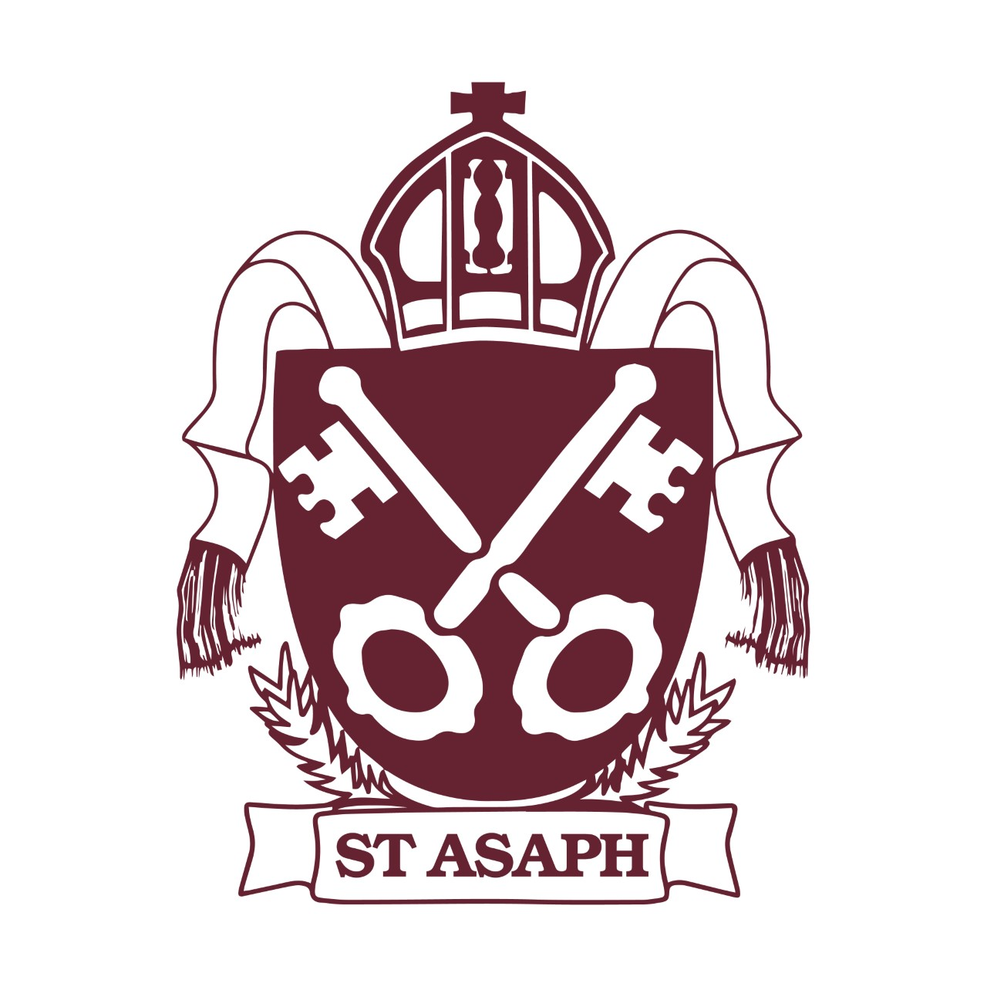
Ysgol yr Holl Saint – All Saints’ School

Digital Champions Meeting

Date: Thursday 23rd January
Present: Digital Leaders, Mr Holmes & Mrs Mort

Agenda
- Internet Safety Day – Tuesday 11th February

Action | Responsible | Due Date
Digital Leaders to ask their classes what they already know about staying safe online and what they would like to learn. | Digital Leaders | 30/01/25
Deliver an assembly on Tuesday 11th February at 9:10am. | Digital Leaders | 11/01/25
Split the Digital Leaders into smaller groups. These groups are to deliver Safety Internet Day workshop to classes based on the results of the questionnaires. | Digital Leaders | 11/01/25
Digital Leaders to collect photos from each class to evidence the Internet Safety Day. | Digital Leaders | 11/01/25
BBC live lesson for Internet Safety Day. | Digital Leaders | 11/01/25

